Support Vector Machine
Code:
import numpy as np
import pandas as pd
import matplotlib.pyplot as plt
import seaborn as sns
from sklearn.datasets import load_breast_cancer
from sklearn.model_selection import train_test_split
from sklearn import svm
from sklearn.metrics import confusion_matrix, classification_report

bcancer = load_breast_cancer()
print(bcancer.feature_names)
print(bcancer.target_names)

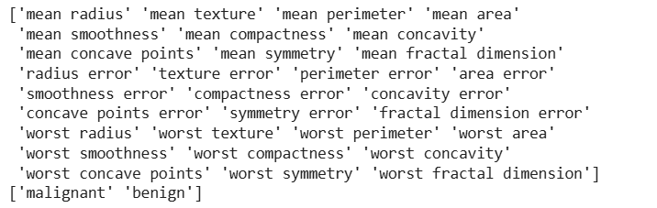

bcancer.data.shape

X_train, X_test, y_train, y_test = train_test_split(bcancer.data, bcancer.target, test_size = 0.3, random_state = 109)

from sklearn import metrics
print("Accuracy",metrics.accuracy_score(y_test, y_pred))
print("Precision",metrics.precision_score(y_test, y_pred))
print("Recall",metrics.recall_score(y_test, y_pred))
print("F1_score",metrics.f1_score(y_test, y_pred))

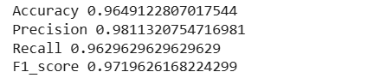

print(classification_report(y_test,y_pred))
print(confusion_matrix(y_test,y_pred))

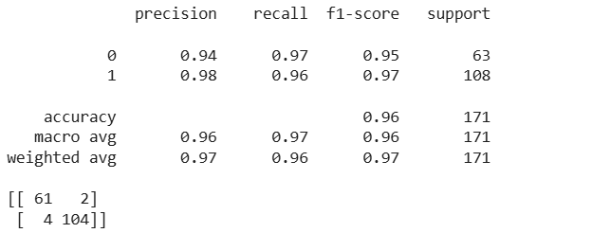

plt.figure(figsize=(10, 6))
plt.scatter(X_train[:, 0], X_train[:, 1], c=y_train, cmap='viridis', alpha=0.7)
plt.legend(['Train Data'])
plt.xlabel('Feature 1')
plt.ylabel('Feature 2')
plt.title('Classification using SVM')
plt.show()

Output:
